**CM1605 Web Technology**

**Tutorial 3**

The aim of this tutorial is to use embedded and external style sheets, practice different CSS selectors and use of CSS float attribute and CSS box model.

This is an individual exercise. You may use any text editor (Notepad, Notepad ++) to create the HTML pages and any Browser application (chrome, IE, firefox etc) to run the web pages.

Note: Use proper indentation and comments where applicable

**Part A**

1. Create the following HTML file on “How AI become an industry”.

<!-- Save as "Tutorial4.html" -->

<html>

<head>

<meta charset="utf-8">

<title>About AI</title>

</head>

<body>

<h1>How AI becomes an industry</h1>

<h2>(1908-1980)</h2>

<p id="para1">The first successful commercial expert system, Rl, began operation at Digital Equipment Corporation (McDermott, 1982). The program helped configure orders for new computer systems, and by 1986, it was saving the company an estimated $40 million a year. By 1988, DEC's AI group had 40 deployed expert systems, with more on the way. Du Pont had 100 in use and 500 in development, saving an estimated $10 million a year. Nearly every major U.S. corporation had its own AI group and was either using or investigating expert system technology. In 1981, the Japanese announced the "Fifth Generation" project, a 10-year plan to build intelligent computers running Prolog in much the same way that ordinary computers run machine code. The idea was that with the ability to make millions of inferences per second, computers would be able to take advantage of vast stores of rules. The project proposed to achieve full-scale natural language understanding, among other ambitious goals.The Fifth Generation project fueled interest in AI, and by taking advantage of fears of Japanese domination, researchers and corporations were able to generate support for a similar investment in the United States. The Microelectronics and Computer Technology Corporation i(MCC) was formed as a research consortium to counter the Japanese project. In Britain, the Alvey report reinstated the funding that was cut by the Lighthill report.In both cases, AI waspart of a broad effort, including chip design and human-interface research.

</p>

<p id="para2">The booming AI industry also included companies such as Carnegie Group, Inference,Intellicorp, and Teknowledge that offered the software tools to build expert systems, and hardware companies such as Lisp Machines Inc., Texas Instruments, Symbolics, and Xerox that; were building workstations optimized for the development of Lisp programs. Over a hundred companies built industrial robotic vision systems. Overall, the industry went from a few million \ in sales in 1980 to $2 billion in 1988.</p>

<hr>

<footer>

<p>This is taken form the book Artificial-Intelligence-Modern-Approach by Stuart J. Russell and Peter Norvig.. Read more</p>

</footer>

<body>

</html>

1. You need to create an ***embedded style*** sheet to add the following styles to the document.
2. **Rule 1 -**Add the following styles to the body element

background-color: lightblue;

font-family: verdana;

font-size: 14px;

1. **Rule 2 -**Add h1 to h2 headers following style

color: white;

text-align: center;

1. **Rule 3 -**Now that the color for h2 does not highlight it as a subheading, add these styles for the <h2> element. Replace blue with a hex color value of your choice. Now what happened to the style applied in **Rule 2** for <h2> element?

color: white;

1. **Rule 4 -**Add the following style to <p> element with id=”para2”

font-style: italic;

1. **Rule 5 –** The text inside the footer element should have the following style.

font-size: 10px;

1. **Rule 6 –** The name of the book “Artificial-Intelligence-Modern-Approach” should appear in red color. Hint: Make use of the <span> element with the attribute – class
2. **Rule 7 –** Read more should act as an anchor tag
3. **Rule 8 –** Apply the following styles to all paragraph elements.

text-align: justify;

**Part B**

1. Include a <div> element which wraps both the paragraph elements. The width of the div element is 1000px and background color: lightgreen.
2. It should have following margins
   1. margin-top: 100px;
   2. margin-bottom: 100px;
   3. margin-right: 150px;
   4. margin-left: 80px;

**Part C**

1. You need to add a navigation bar to the same web page. We make use of <nav> element to specify the navigation bar. Add the following code.
   1. Why <nav> element?
   2. <a href="#home"> what does ‘#’ ?
   3. Save the file and see the output

<nav>

<ul>

<li><a href="#home">Home</a></li>

<li><a href="#news">Future of AI</a></li>

<li><a href="#industries">AI Industries</a></li>

<li><a href="#about">About The book</a></li>

</ul>

</nav>

1. You need to remove the bullets to make your list look like a navigation bar (list-style-type: none;) and extra padding and margins.

ul {

list-style-type: none;

margin: 0;

padding: 0;

}

1. Add the below style to <nav> element

nav {

background-color:black;

}

1. You need to create a horizontal navigation bar, Use the CSS style inline-block; and give some padding to the navigation bar.

li {

display: inline-block;

text-align: center;

padding: 14px 16px;

}

1. You need to add style to links, and remove the default underline style.

li a {

display:inline-block;

text-decoration: none;

color:#fff;

}

1. What is the use of the descendant selector li a?
2. Can you use it like this nav a?
3. What happens if you use only a?
4. Change the link color on hover, Using the **a link pseudo-class. Save and see the output in the browser**

li a:hover {

background-color: blue;

color: white;

}

1. You are in the Home page, therefore you need to show the active link/current link. Hint: The Home button should be highlighted.

**Part D**

1. You need to create an external style sheet and add a link to the web page. Use **Tutorial4startup2.html.**
2. Create a web page that has two columns to display the two categories on AI definitions.
3. Hint: use div element tags with CSS id's to create these two areas. Both div elements should have width 50%.
4. Place the category headings in h3 header and Main heading in h1 header, align-centered.
5. Make use of the **CSS float attribute**: the first div element should be floated to right and the second div element floated to left.
6. Add an image to right div element can make it float to right.
7. Add a padding of 1% to the column 1.
   1. What issues arise?
   2. How do you overcome?

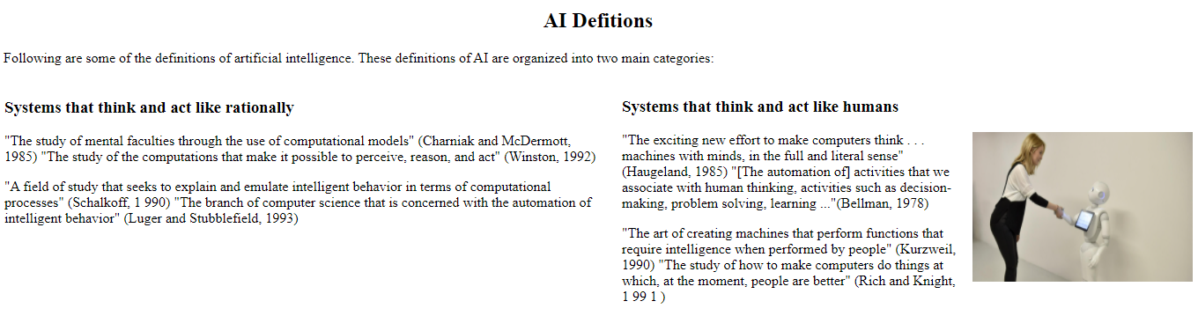

Figure 1: Sample Output